* MAKING A CLOCK WITH PYTHON:

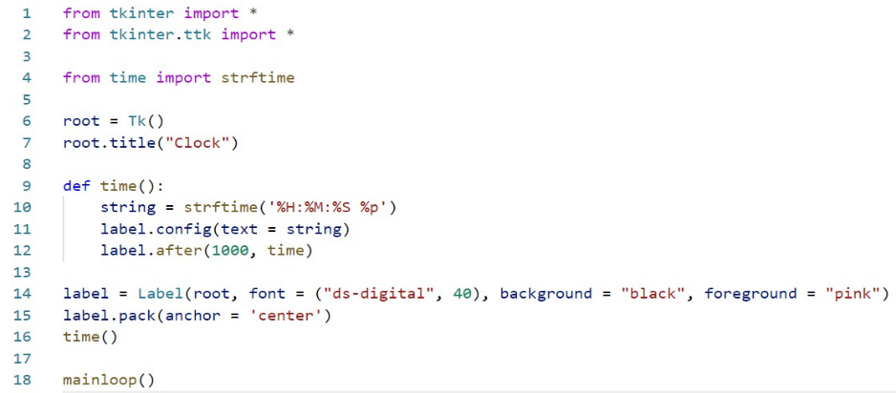INPUT:

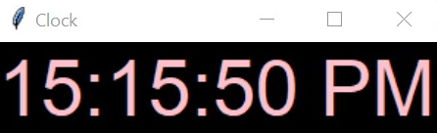 OUTPUT:

* MAKING A Calculator WITH PYTHON:

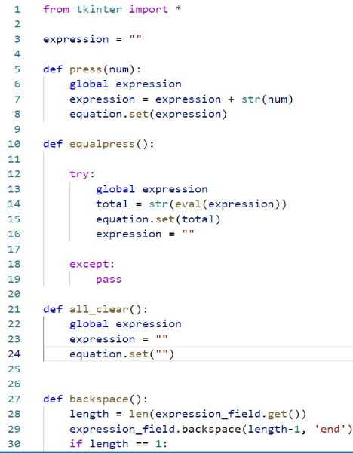INPUT:

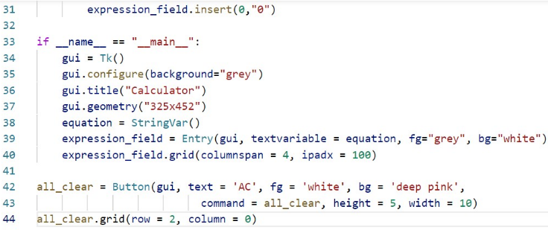

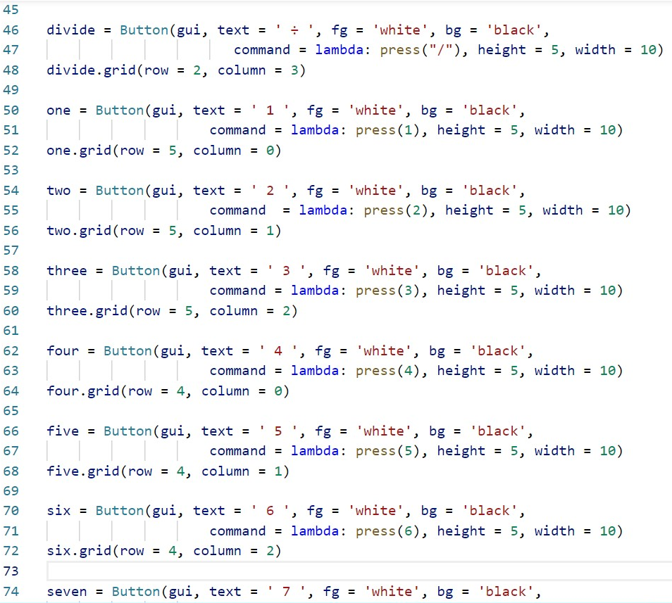

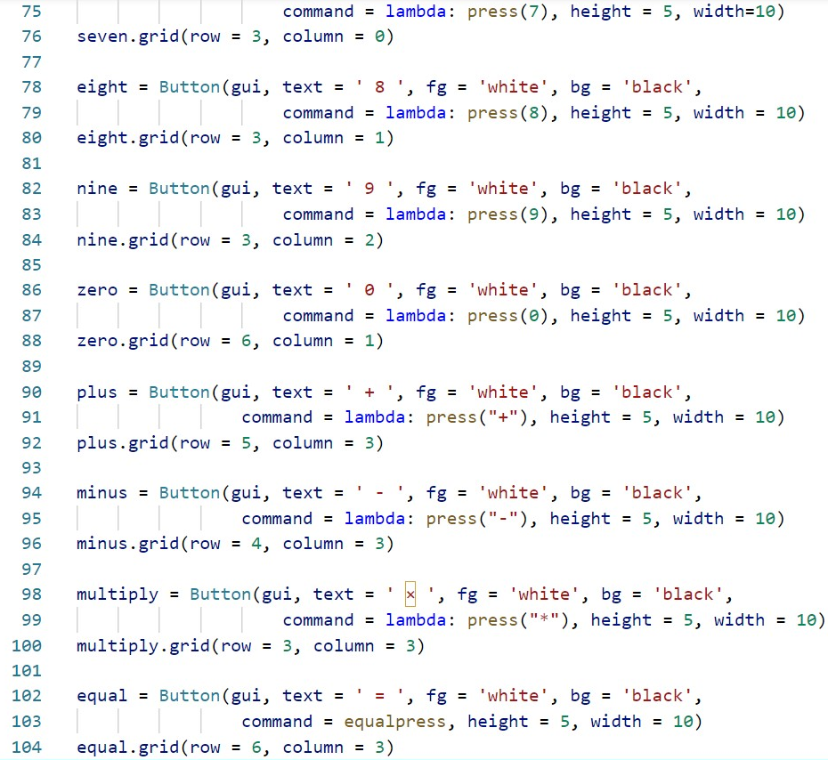

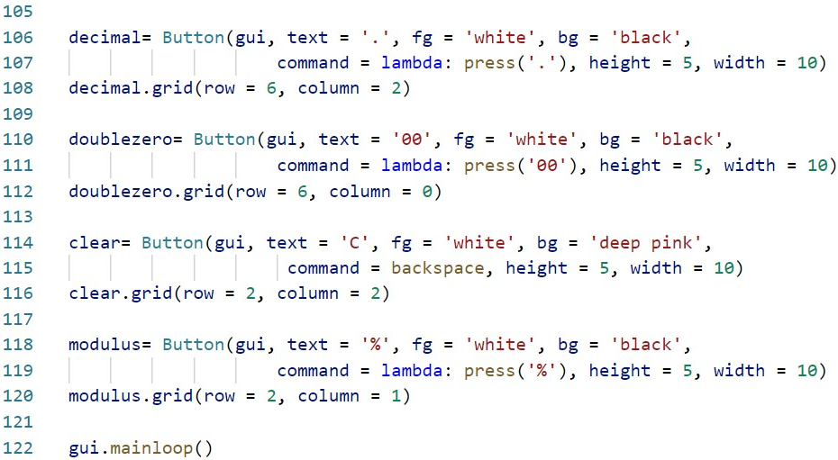

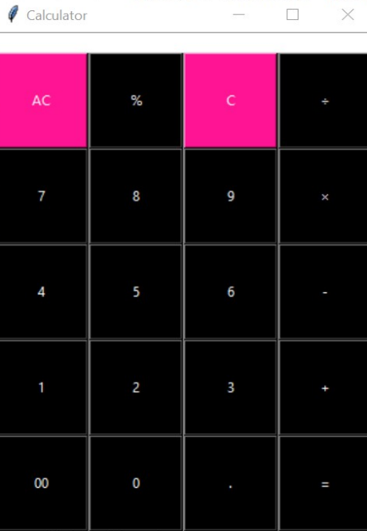 OUTPUT:

* MAKING A program WITH PYTHON to Automatically send a message to someone through ***whatsapp*** in just 1 second:

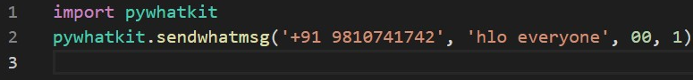INPUT:

OUTPUT:

After one sec. your whatsapp web on pc will be opened in your web browser and after it is opened it will be automatically will show that the message(‘hlo everyone’) has been send to (9810741742).   
Note: Here phone no. and the message which needs to be send can be changed.

________________________________________________________________

THE

END